**GameAnalytics Guideline (ASP.NET MVC Rest API)**

**By Shahzaib Khan**

**Email :** [**shahzaibkhan0122@gmail.com**](mailto:shahzaibkhan0122@gmail.com)

**Cell : 03492590471**

1. Create Database in SQL and Mongodb scripts and file are in folder name Database
2. Change Connection string in GameAnalyticsWebApi project in Web.config for both SQL Server database and Mongodb.

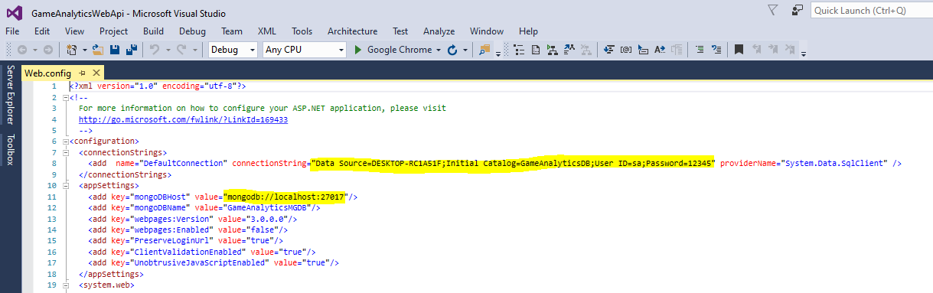

1. Change Connection string in EmailSchedular console project in App.config for both SQL Server database and Mongodb.

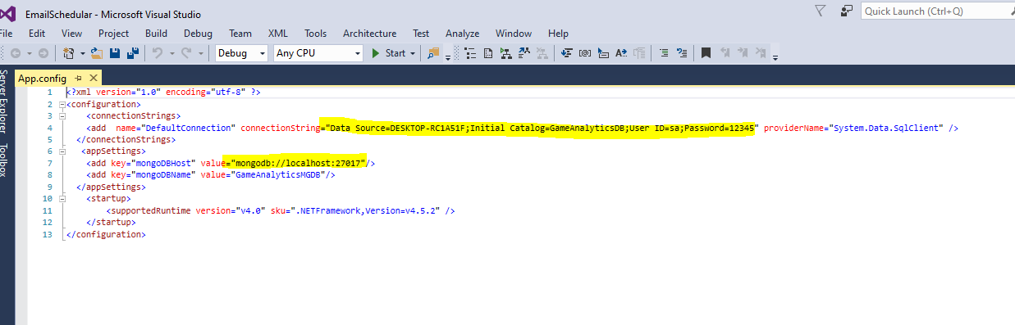

1. For post Api Url is

<http://localhost:7835/api/GameAnalyticsApi/Post>

and Body is

{

"Full_Name":"Shahzaib Khan",

"Email":"shahzaibkhan0122@gmail.com",

"Game_Metric_Score_1":"1400",

"Game_Metric_Score_2":"2000",

"Time":"2022-12-17",

"EventType" :"months"

}

And response will be

"{\"Status\":\"Success\",

 \"UserID\":\"9265DD28-9C11-4CC7-958B-669F12DFCADA\"

}"

1. For Get api Url is

<http://localhost:7835/api/GameAnalyticsApi/Get>

and Body is

{

"Eventtype" :"months",

"datefrom": "2022-12-01",

"dateto": "2022-12-31",

"Userid":"9265DD28-9C11-4CC7-958B-669F12DFCADA "

}

Eventtype should be in {Events, Days, Weeks, Months, Years}

Response will be

"[{\"Time\":\"2022-12-17T00:00:00Z\",

\"Game_Metric_Score_1\":1400,

\"Game_Metric_Score_2\":2000,

\"Count\":1}]"

1. Email schedular will fire dummy email to the user who are between the range of current month.